HARDWARE AND COMPONENTS BASICS

ASSIGNMENT DAY 3
TASK1. Create a comparison table listing the main differences between DDR3, DDR4, and DDR5 RAM, including speed, voltage, and typical use cases.
Feature | DDR3 | DDR4 | DDR5
Release Year | 2007 | 2014 | 2020
Speed Range | 800–2133 MT/s | 2133–3200 MT/s | 4800–8400+ MT/s
Voltage | 1.5V | 1.2V | 1.1V
Power Consumption | Higher | Lower | Lowest
Capacity per Module | Up to 16 GB | Up to 64 GB | Up to 128 GB+
Performance | Basic | Good | Excellent
Cost | Cheapest | Moderate | Most Expensive
Typical Use Cases | Older PCs, office work | Modern laptops and desktops | Gaming PCs, AI workloads, high-performance systems

TASK2. Open your laptop or desktop (with power disconnected), locate the RAM slots, and take a clear photo of the installed RAM module. Reinstall the RAM module and verify that your system boots up successfully.<br><br><em><strong>Hint:</strong> Refer to your device manual or a trusted YouTube guide if unsure about RAM removal and installation steps.</em>
STEP 1-SHUT DOWN THE LAPTOP
STEP2-OPEN THE BACK OF THE LAPTOP
STEP3-LOCATE THE RAM MODULE(here we can find the RAM )
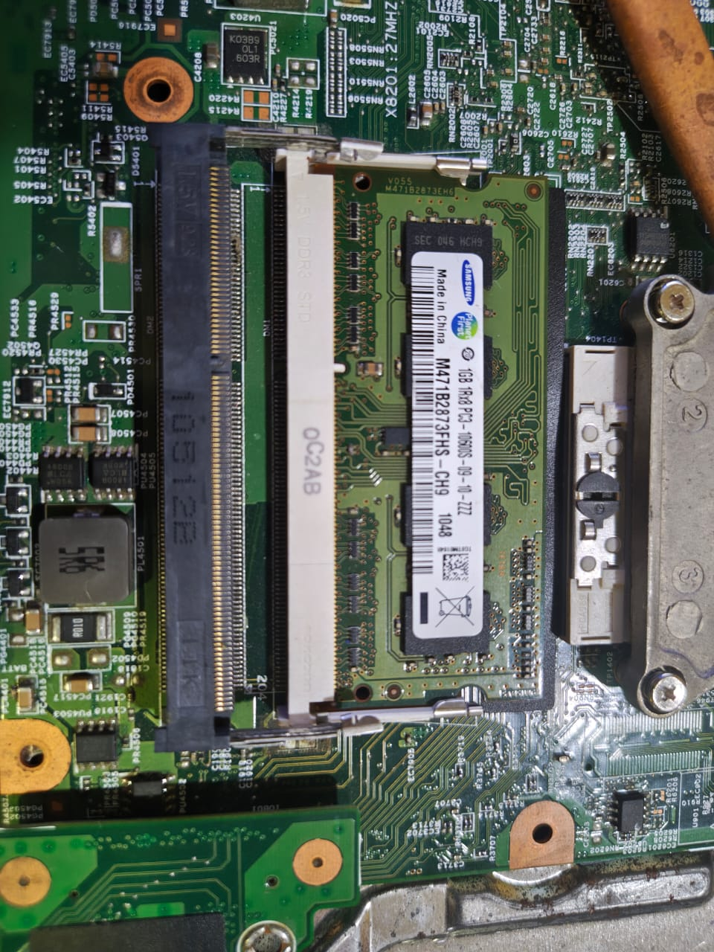

STEP4-REMOVE THE RAM
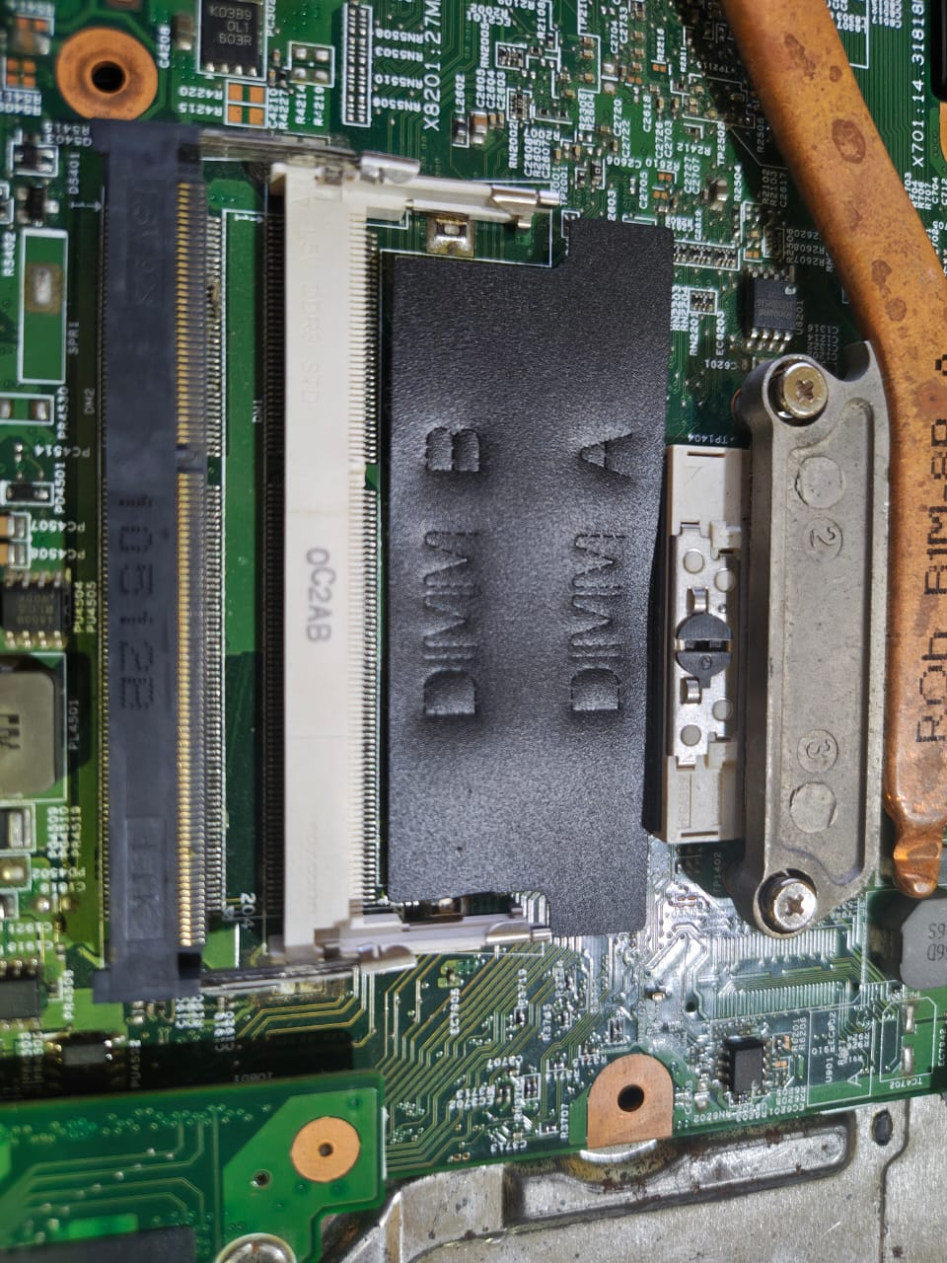
STEP5-RE-INSTALL THE RAM
STEP6-REASSEMBLE THE LAPTOP
STEP7-VERIFY THE SYSTEM BOOT

TASK3. List three key differences between HDD, SSD, and NVMe storage types, and for each, name one app or use case (from apps you use daily) that would benefit most from that storage type.
Feature | HDD | SSD | NVMe SSD
Technology | Magnetic Disk | SATA Flash Memory | PCIe Flash Memory
Speed | Slowest | Faster | Fastest
Moving Parts | Yes | No | No
Durability | Lower | Higher | Higher
Noise | Audible | Silent | Silent
Cost | Cheapest | Moderate | Highest

TASK4. Remove the storage drive (HDD or SSD) from your system, take a photo of the connector type (SATA, M.2, or NVMe), and reinstall the drive. Confirm that your device recognizes the storage after reassembly.<br><br><em><strong>Constraint:</strong> Only perform this task if you have access to a device you are allowed to open. If not, find and share a YouTube video link showing the process for your laptop/PC model.</em>
STEP1- Shut Down the Laptop
STEP2-Open the Back Cover
STEP3-Locate the Storage Drive
STEP 4-Remove the SSD
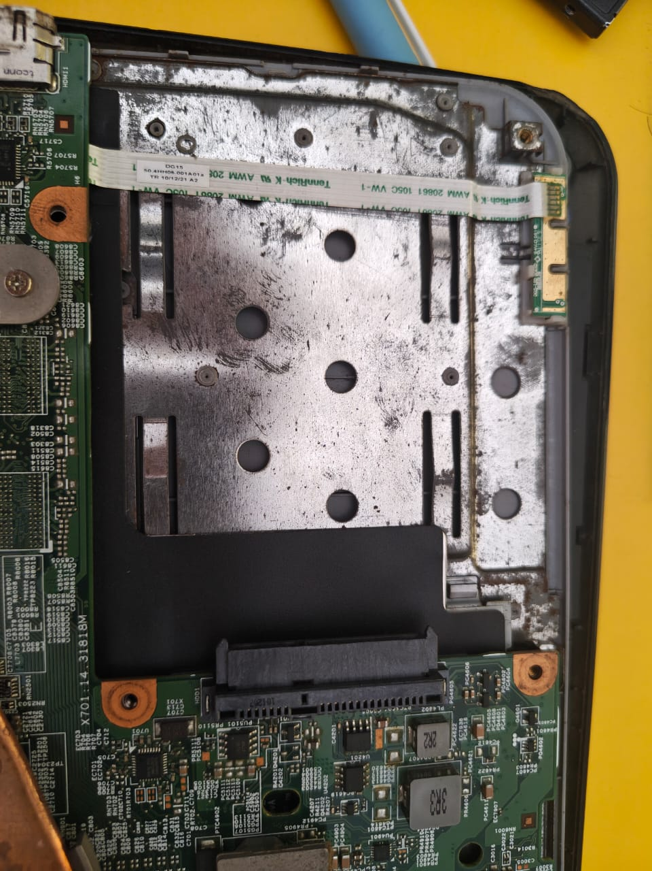
STEP5- Identify the Connector Type
STEP6-Reinstall the SSD
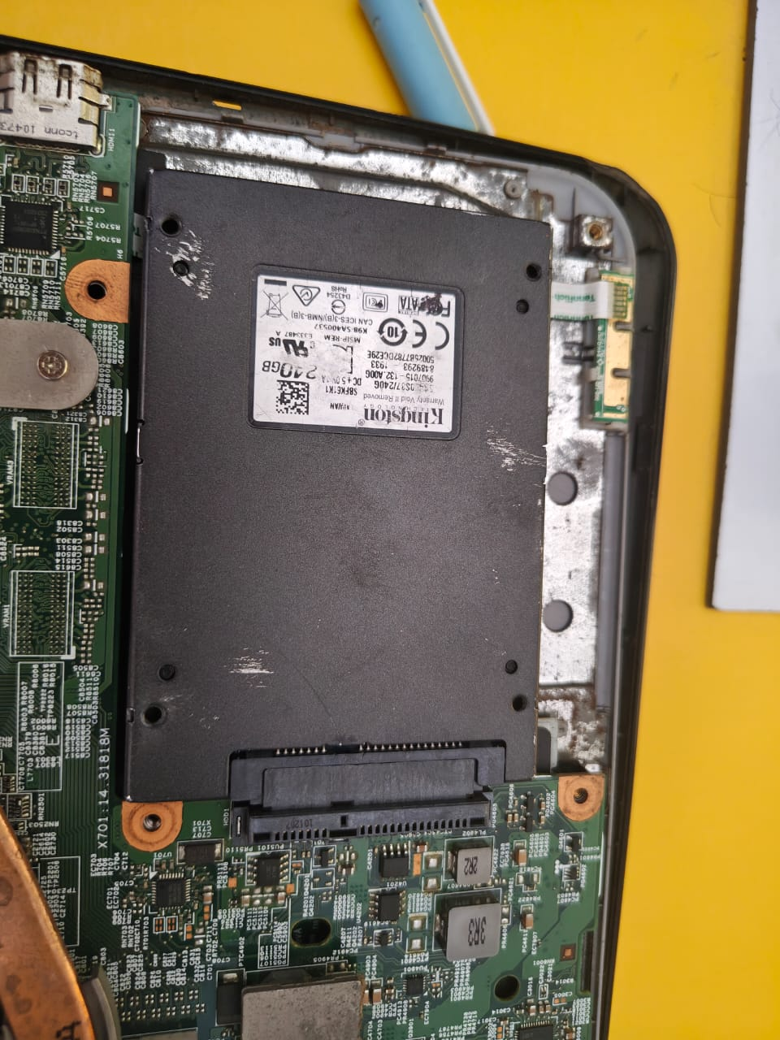
STEP7-Reassemble the Laptop
STEP8-Verify Storage Detection

